Using the pen tool, shape builder, shapes and at least 15 colors, you will create a simple still life of at least 3 objects, 2 of the 3 must overlap. Set up a still life of your own and photograph it (camera phone is sufficient) and use it as a reference. If you haven't used this software much before, I recommend avoiding objects with lots of texture (fur on stuffed animal for example) or very complicated shapes.
MAIN TUTORIAL VIDEOS FOR THIS PROJECT ARE ON THE ILLUSTRATOR TUTORIALS PAGE. An additional one for high-key and low-key is toward the bottom of this page.
Overlap at least 2 objects - that will give a sense of depth without having to due lots of shadows and highlights.

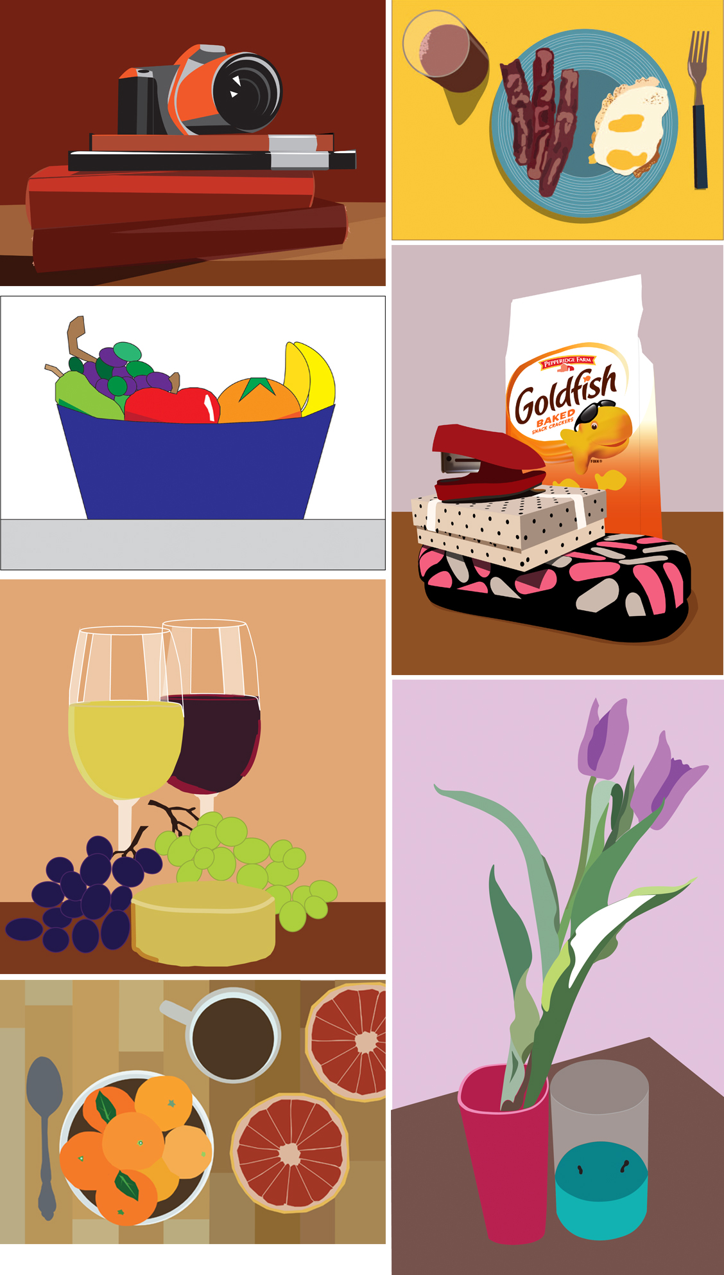
Written Component 300 words minimum
- Color and value use in combination with how color is used: expressively, descriptively, or symbolically?
- How does the saturation and value range change the impression of the image?
- How did you use 2D Principles and Elements to create your focal point (and what is it)? For example, does your focal point have more saturated color? more texture, bigger size, etc? If you have forgotten them, here is a reminder: elements_principles.pdf
- OBJECTIVES: Improve skills using the pen tool in Illustrator
This project requires the use of the pen tool to create paths. You will also want to use the Shape Builder tool and Path finder tool . It is possible for you to use a few pre-made shapes such as a circle for an orange but you will probably have to adjust it with all the path-related tools such as the ‘convert anchor point’ tool.
- Though you may not use the "Trace" option, you may use a photographic reference to begin building your objects. Use a photo as a layer underneath to make this easier.
- Bring in an image to use as a reference. You may set up a still-life at home and take a picture. Or you could find a painting or photograph and re-do it in Illustrator. Objects could be typical things found in a traditional still-life such as fruit. Or you may create a still-life of objects you care about or things that represent you. For example: a hat with a sports team logo, a stuffed animal, snacks, etc. You need at least 3 objects in the drawing but often 5 look better. For example, for a fruit still-life - it could include a bowl, 2 apples, a pear, a banana, etc. Optional - gradients, patterns.

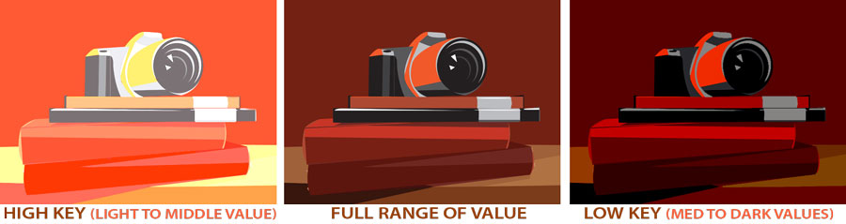

PROJECT BASICS You must use 4 different art boards in one Illustrator file.
ARTBOARD 1: Black and white line only – just like a coloring book
ARTBOARD 2 : “Normal” descriptive colors: -- Use at least 15 distinct colors and high contrast.
You could have many variations and values of one color included in the 15 colors, for example (a light blue, medium blue and dark blue would count for three).
ARTBOARD 3: High Key - all light to medium values
ARTBOARD 4: Low Key - all medium to dark values

TURN IN:
FOR CRITIQUE: jpg of at least 2, B & W + 1 color variations
FOR GRADE: Illustrator file with 4 artboards, jpg of each variation

